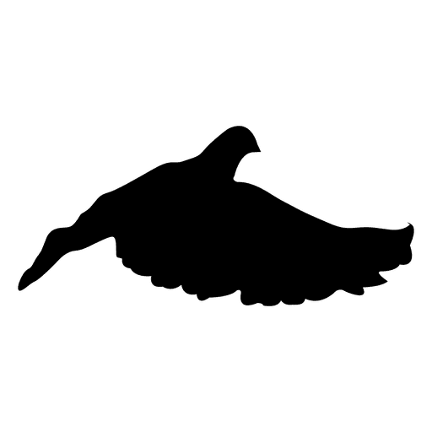
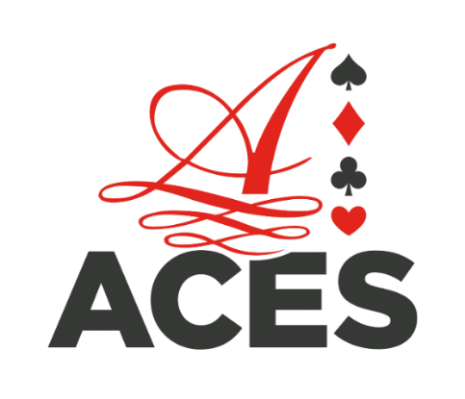
Schenectady’s 2024
WILD Kit Race
3,000 pts 1st place*
500 pts 1st Aces Wild*
500 pts 1st Free Band*
*Denotes participation
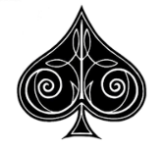
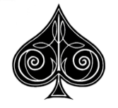
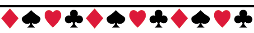

Auction Entry Fee: Single kit is $50, three kits for $125. If you buy six kits, get the seventh free to place in the loft of your choice to compete for a separate free band prize.

Auction date: February 10, 2024 (February 17th: snow date)
Doors open at 11am, Auction at 12pm
Race date: October 5, 2024 (dependent on weather.)
Bidding starts at $30 a kit (a kit is two birds)
50/50 Split Breeder/Handler
After buying three kits of someone else’s, you will receive one ACES WILD band for each kit purchased after the first three. ACES WILD birds fly for the main prizes as well as ACES WILD prizes.
FOR 2024 HIGH ROLLER KIT
High Roller Kits are $150 (one band, and a backup) place them in the loft of your choice! Main bird competes for High Roller prize, unless backup is sent instead.
All breeders must use the special bands issued by the Schenectady Homing Pigeon Club. All birds are expected to be in handler’s possession by June 15th. Birds become property of the handler unless prior arrangements made. Payment is expected in full by June 15, 2024. Race committee decisions are final.
Race Station will be Westfield, NY. Minimum distance 260 miles or by invitation.
Ron Warbach 518-530-2859♥♦♠♣ Jason Desingue 518-858-3606 Nick Verdicchio 518-365-2591
Committee Fees: $25 per loft, $3 per bird to ship. Max to be paid $100 for shipping.

